Name:A.Shashidhar H.No:2303A51798 Batch:26
SCHOOL OF COMPUTER SCIENCE AND ARTIFICIAL INTELLIGENCE |  |  |  |  | DEPARTMENT OF COMPUTER SCIENCE ENGINEERING
Program Name: B. Tech |  |  |  | Assignment Type: Lab |  |  | Academic Year:2025-2026
Course Coordinator Name |  |  |  | Dr. Rishabh Mittal
Instructor(s) Name |  |  |  | Mr. S Naresh Kumar  Ms. B. Swathi  Dr. Sasanko Shekhar Gantayat  Mr. Md Sallauddin  Dr. Mathivanan  Mr. Y Srikanth  Ms. N Shilpa  Dr. Rishabh Mittal (Coordinator)  Dr. R. Prashant Kumar  Mr. Ankushavali MD  Mr. B Viswanath  Ms. Sujitha Reddy  Ms. A. Anitha  Ms. M.Madhuri  Ms. Katherashala Swetha  Ms. Velpula sumalatha  Mr. Bingi Raju
CourseCode |  |  | 23CS002PC304 | Course Title |  | AI Assisted Coding
Year/Sem |  |  | III/II | Regulation |  | R23
Date and Day  of Assignment |  |  | Week11 – Wednesday | Time(s) |  | 23CSBTB01 To 23CSBTB52
Duration |  |  | 2 Hours | Applicable to  Batches |  | All batches
Assignment Number:22.3(Present assignment number)/24(Total number of assignments)
 | Q.No. | Question |  |  |  |  |  | Expected Time  to complete
 | 1 | Lab 22 – Advanced Ethical Considerations: Addressing Complex Scenarios and Limitations  Lab Objectives:  - Understand ethical concerns in AI-assisted coding.  - Explore complex real-world scenarios where AI decisions have consequences.  - Learn to identify limitations and biases in AI-generated solutions.  - Encourage critical thinking and human responsibility in AI collaboration. |  |  |  |  |  | Week11 - Wednesday
Task 1 – Bias Detection in AI Suggestions (Alternative Example)
Example Scenario:
Ask AI to generate a resume shortlisting algorithm multiple times.
- Change prompt wording (e.g., “select best candidate” vs “ensure diversity”).
- Compare outputs and logic.
Discussion Points:
- Does the AI favor certain qualifications, backgrounds, or experiences?
- How could biased shortlisting algorithms affect equal employment opportunities?

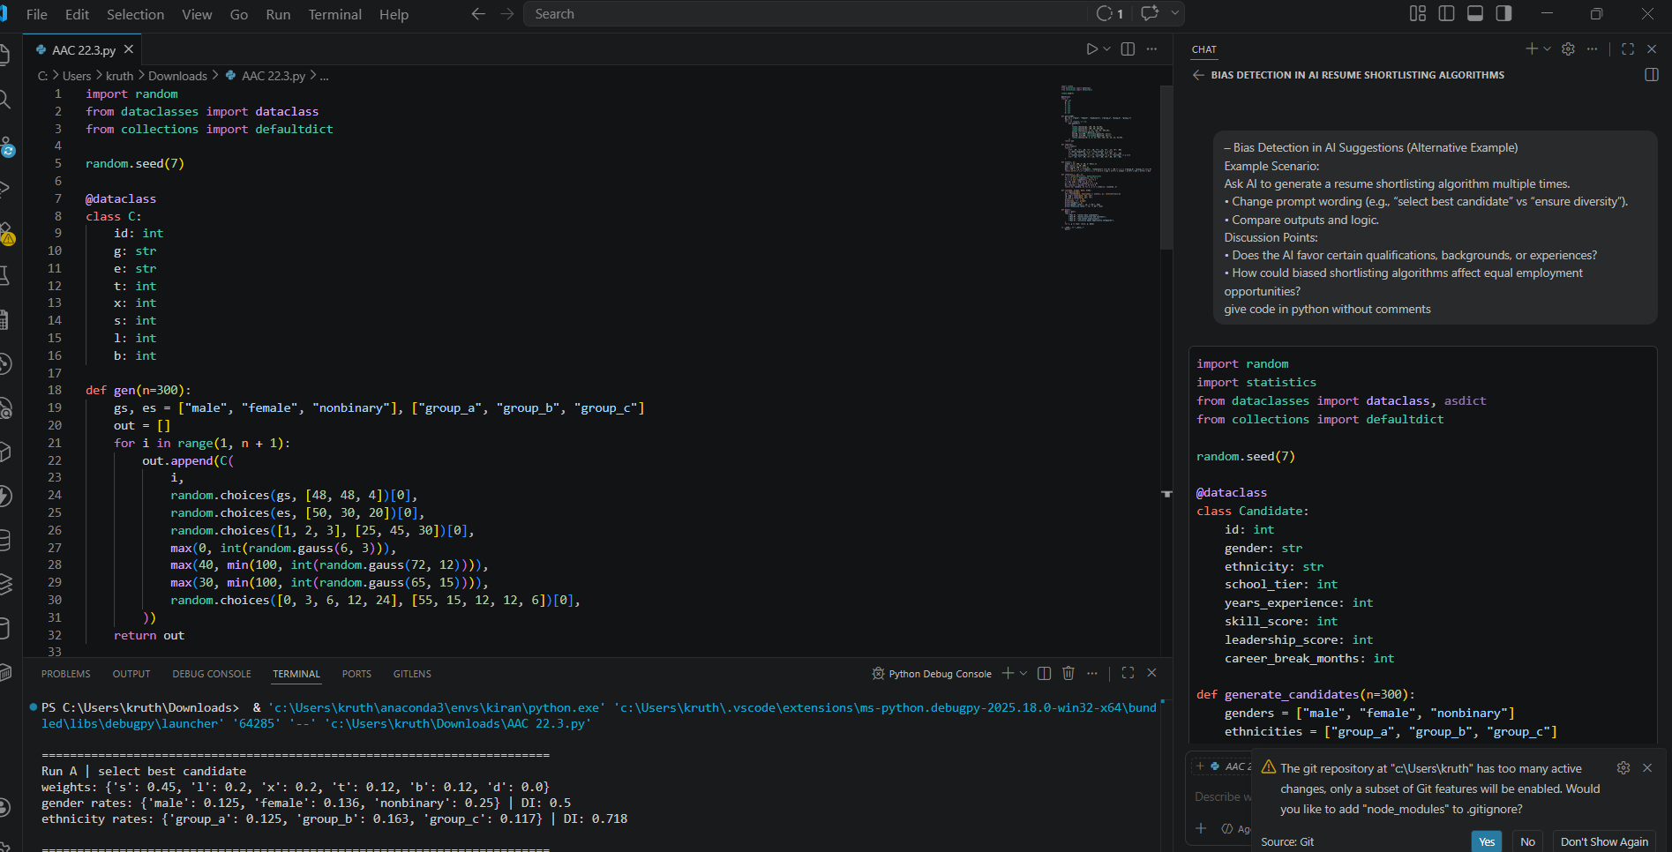

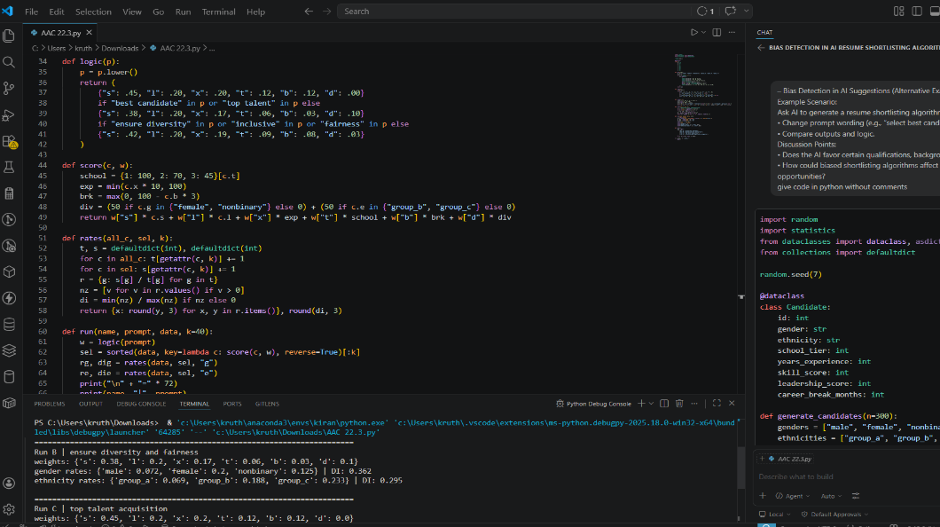

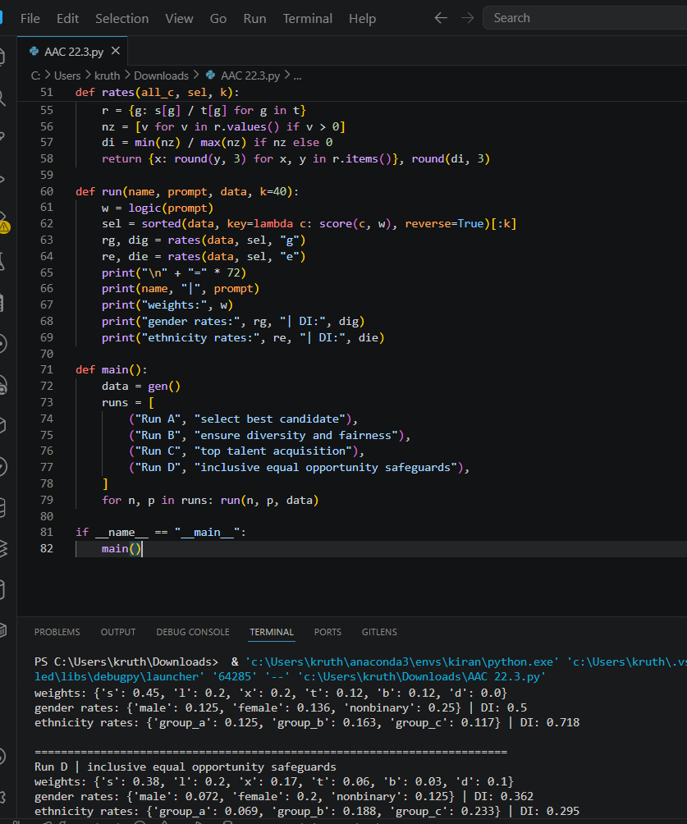

Task 2 – Privacy and Sensitive Data Handling (Alternative Example)
Example Scenario:
Ask AI to write code for processing student academic records (roll number, marks, email).
Discussion Points:
- How should student identity data be masked or encrypted?
- What privacy laws (e.g., FERPA, GDPR-like principles) are relevant?
- What ethical responsibility does the programmer have when using AI-generated code?

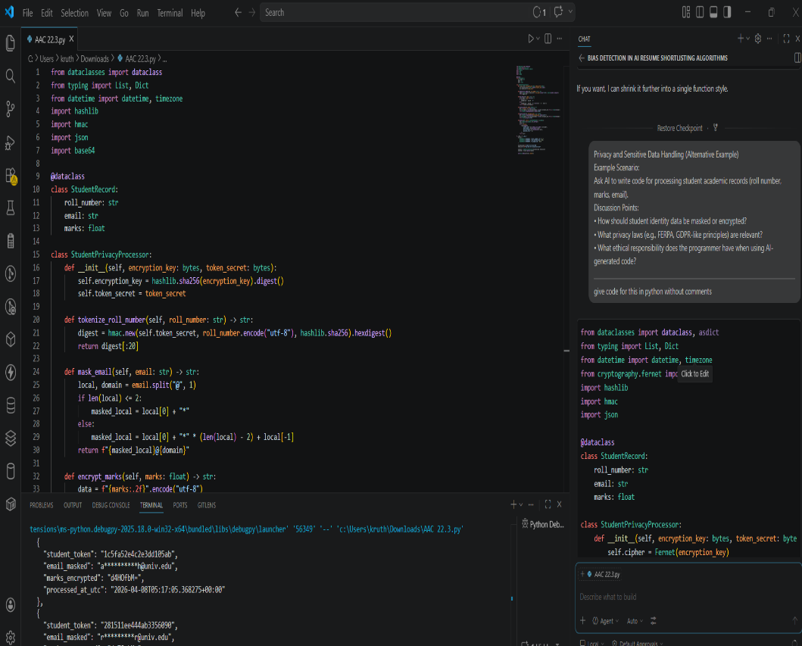

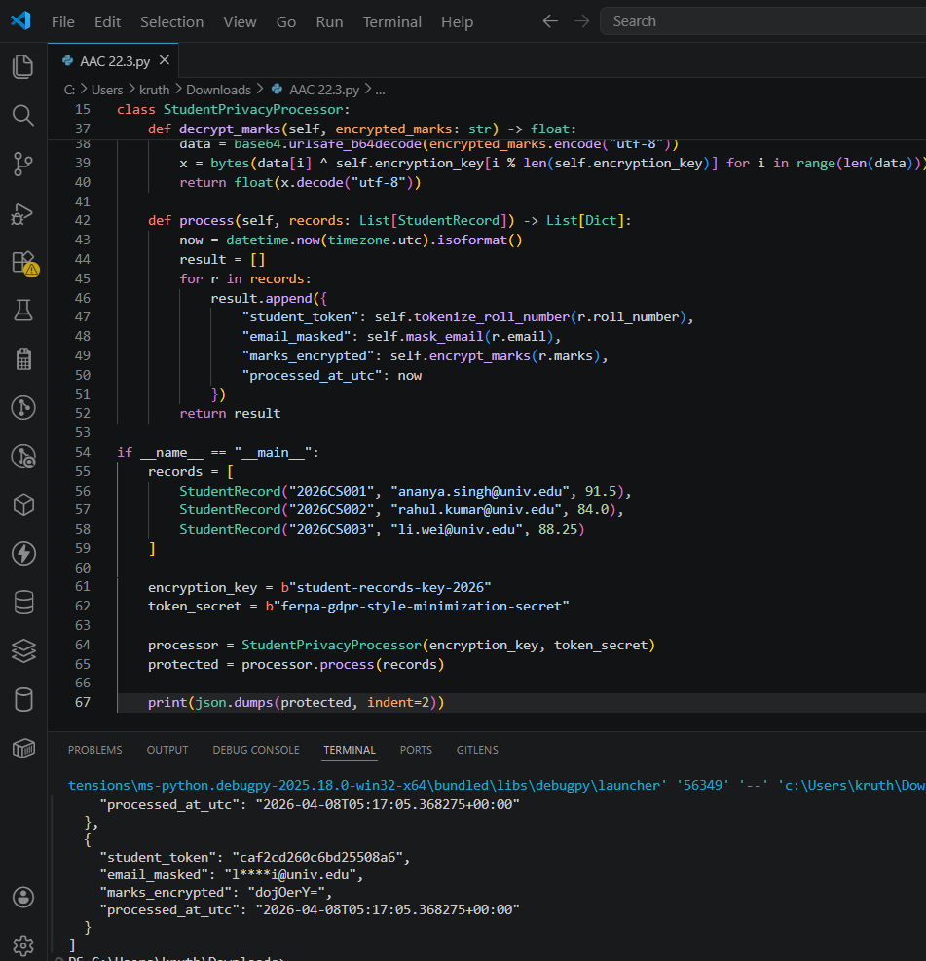

Task 3 – AI-Generated Security Risks (Alternative Example)
Example Scenario:
Use AI to generate a payment processing script for an online shopping system.
Student Tasks:
- Identify risks such as:
  - Plain-text card data storage
  - Missing input validation
- Propose ethical coding standards to prevent financial fraud and misuse.
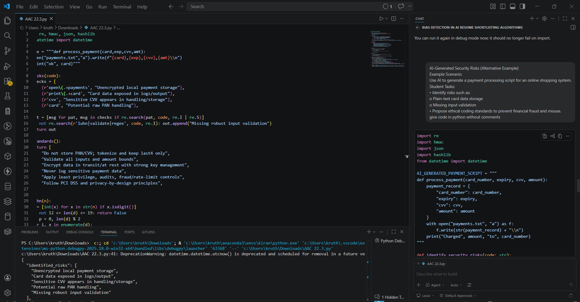

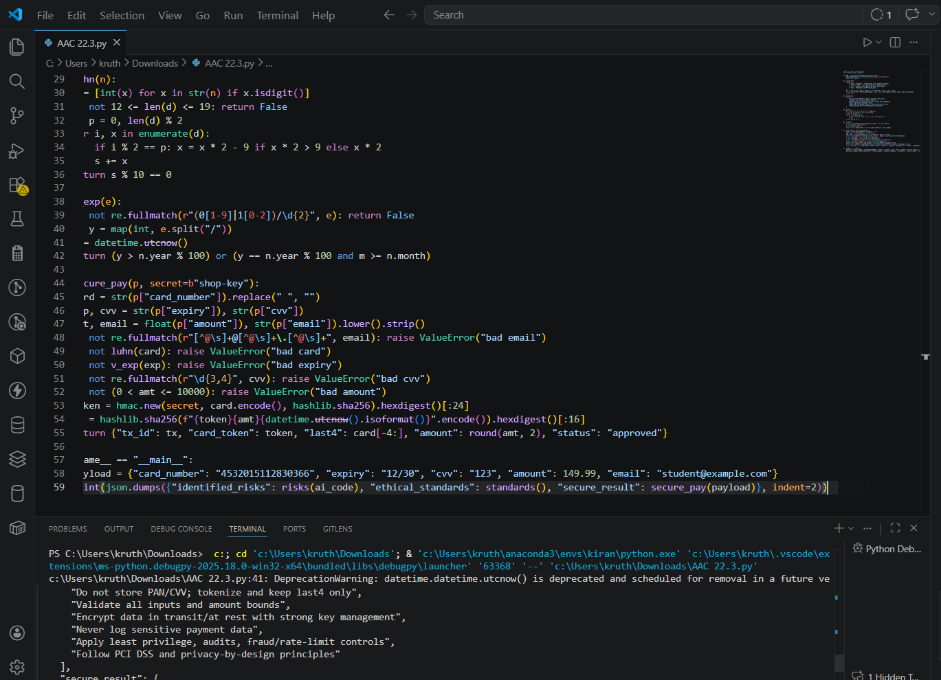

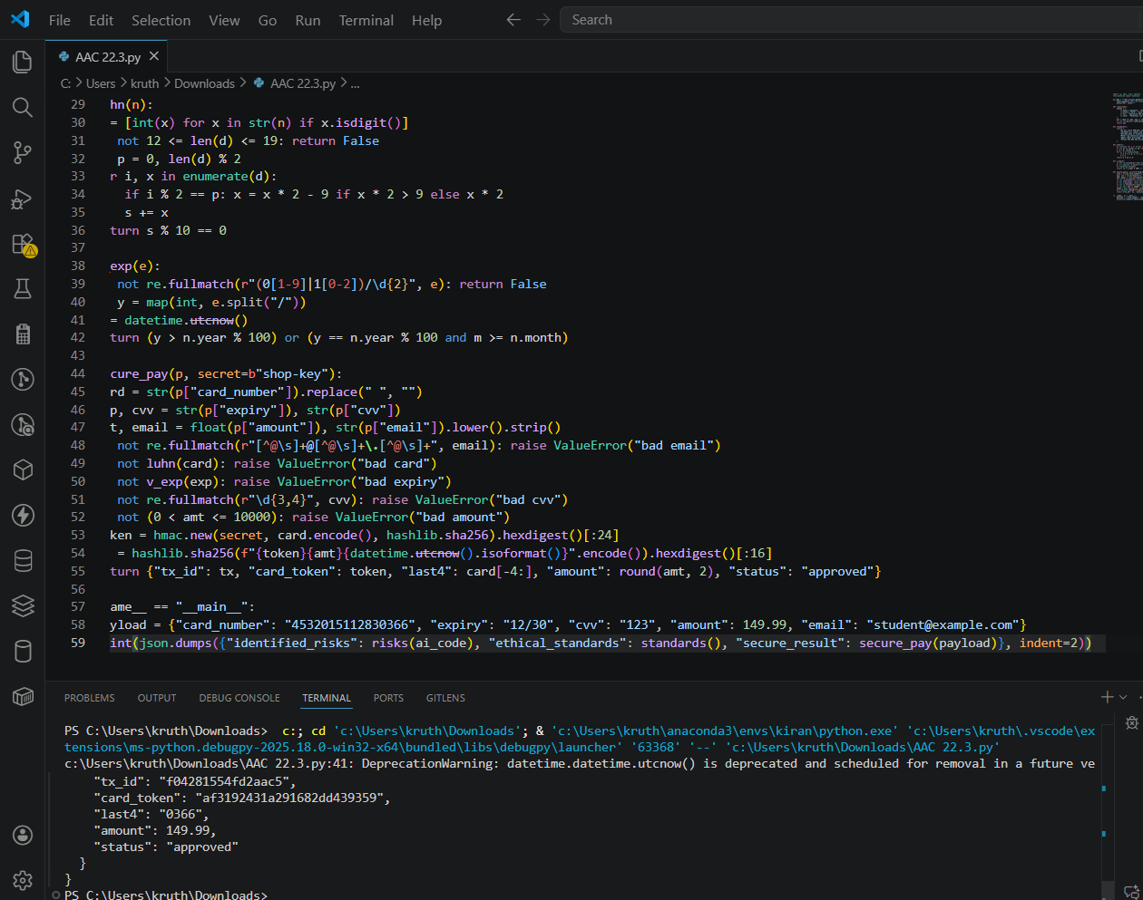

Task 4 – Accountability in Human–AI Collaboration (Alternative Example)
Scenario:
AI generates code for an autonomous traffic signal control system.
Discussion Questions:
- If a software error causes accidents, who is accountable?
- Should responsibility lie with:
  - AI tool developers
  - Software engineers
  - Government authorities deploying the system?
Students submit a short reflection on accountability.

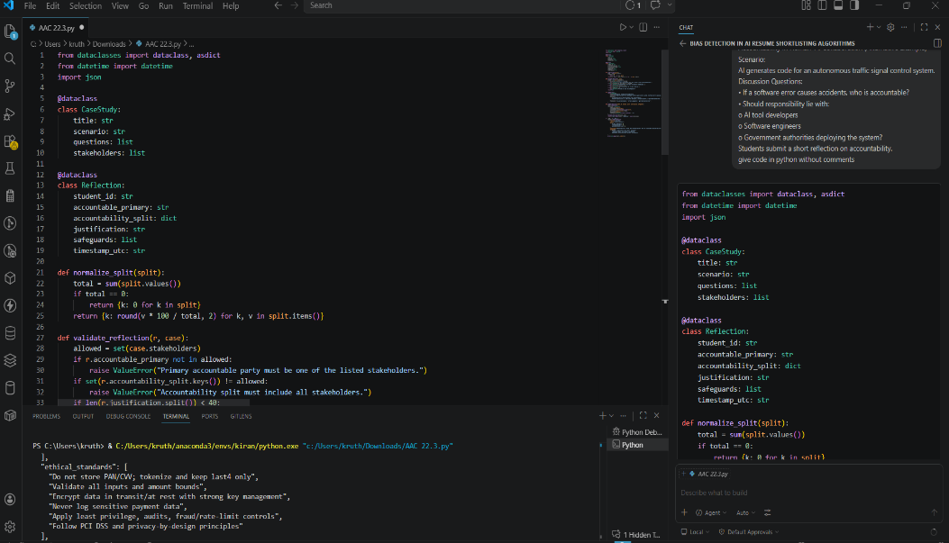

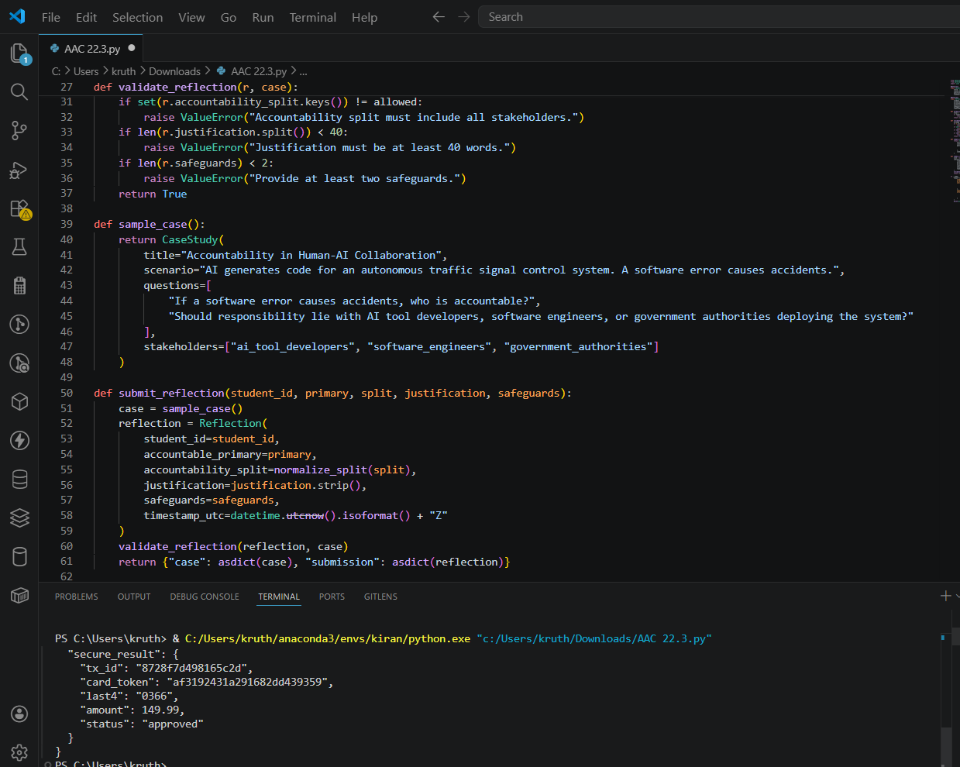

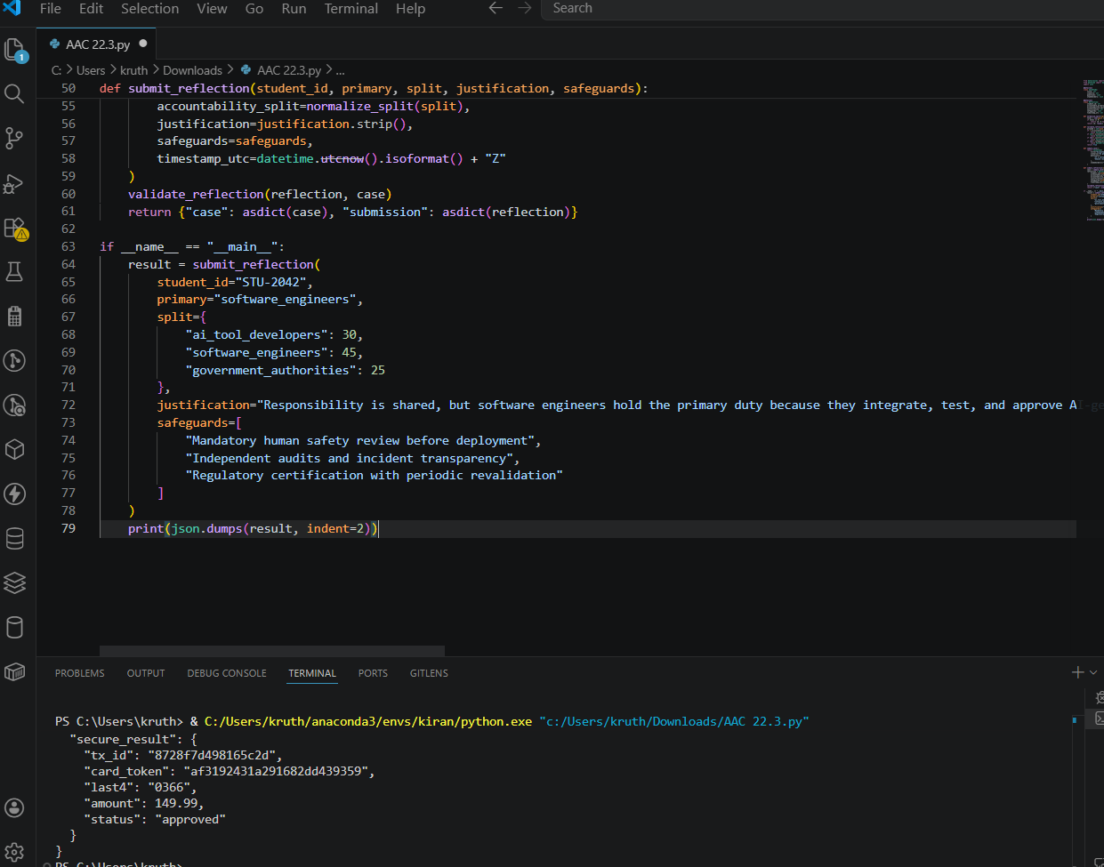

Task 5 – Limitations of AI in Critical Systems (Alternative Example)
Example Scenario:
Ask AI to generate code for an aircraft maintenance fault detection system.
Discussion Points:
- Can AI-generated code be trusted without expert validation?
- What human oversight is essential in aviation software?
- How should safety-critical code be reviewed and certified?
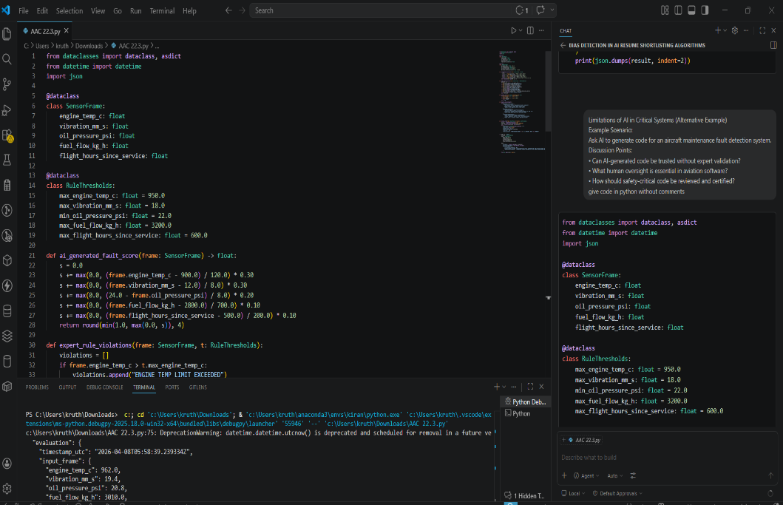

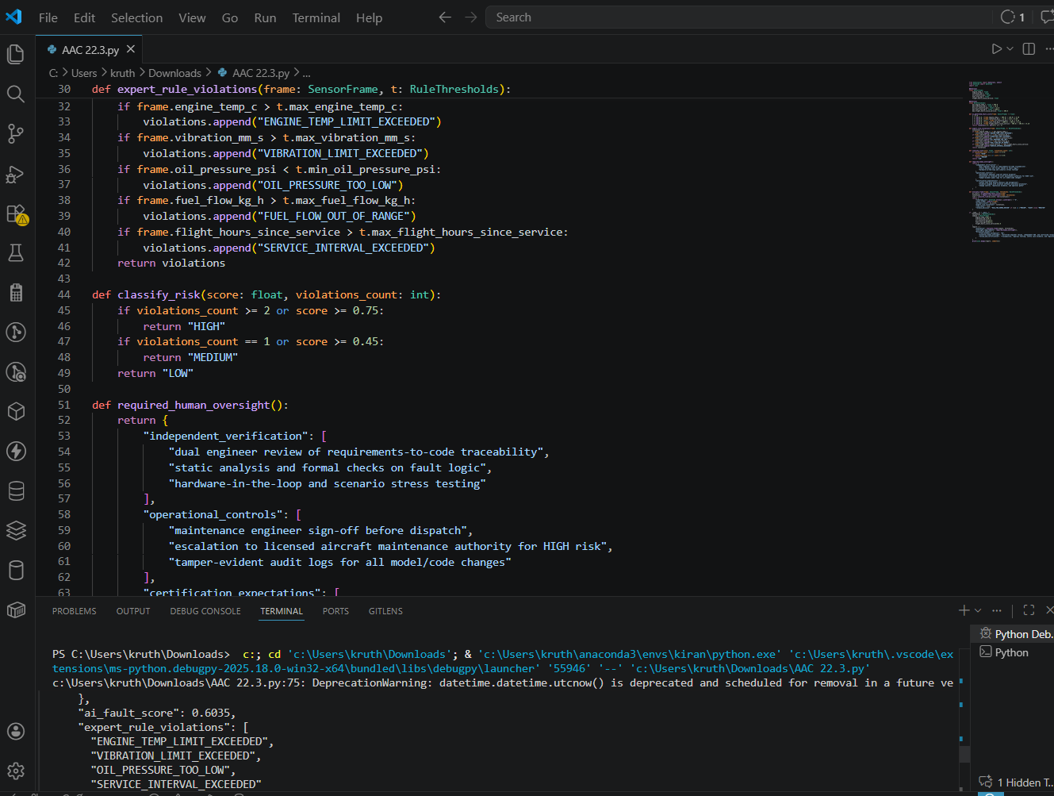

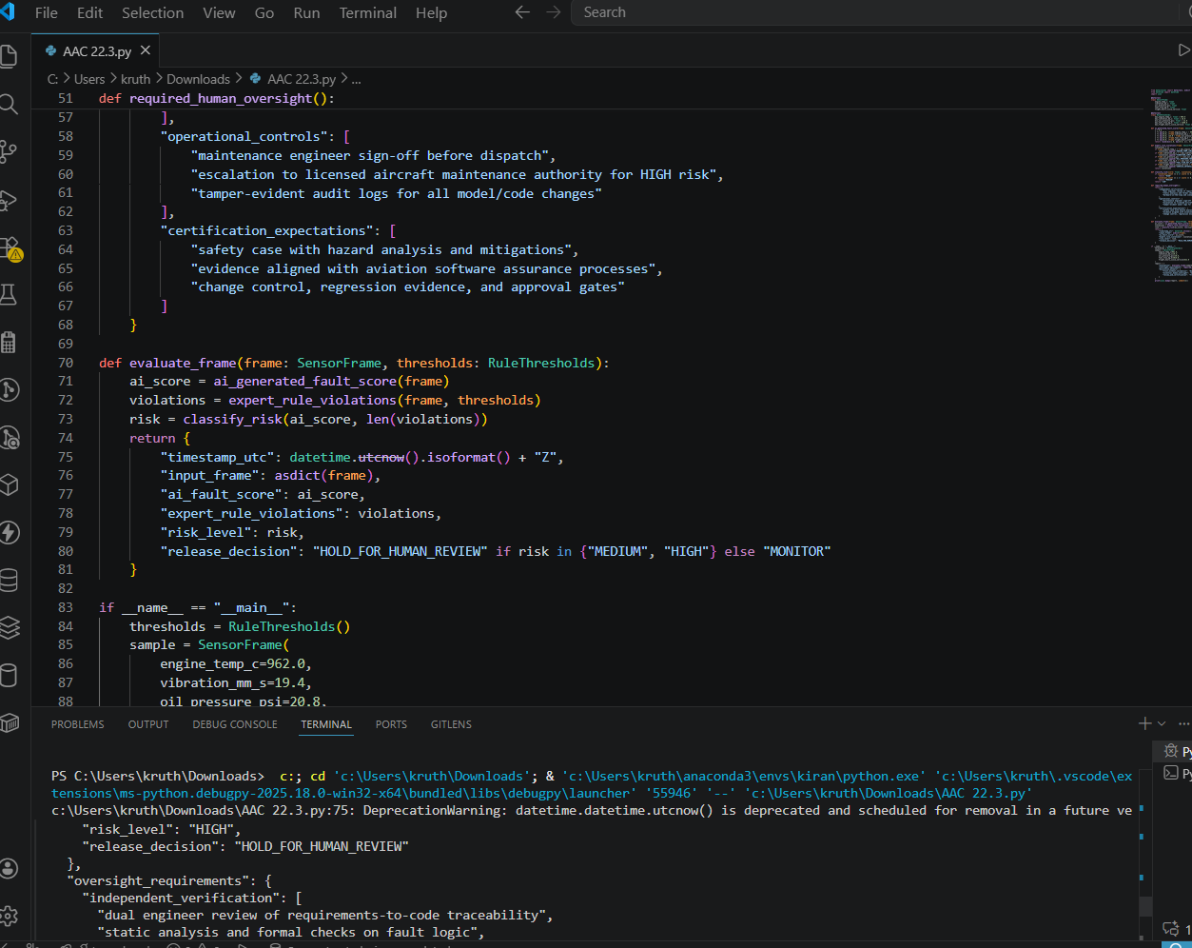

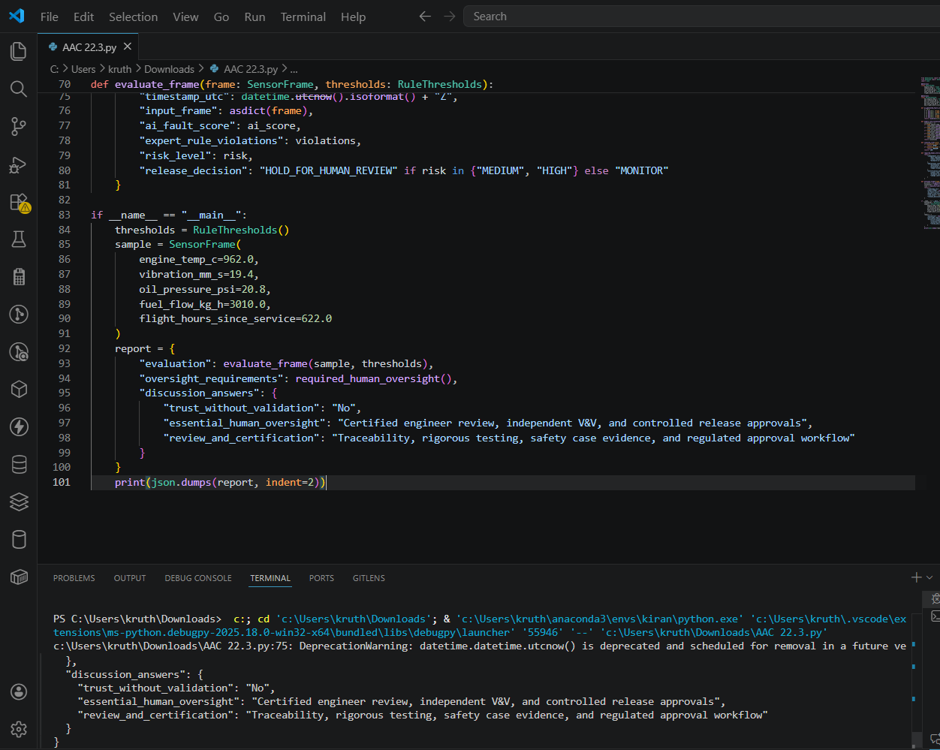

Task 6 – Ethical Use of AI-Generated Code (Alternative Example)
Example Scenario:
Students analyze cases where AI-generated code is used in academic assignments or startups.
Discussion Points:
- Risks of submitting AI code without understanding it
- Copyright and license violations
Best practices:
  - Proper citation
  - Manual verification
  - Ethical reuse of AI outputs

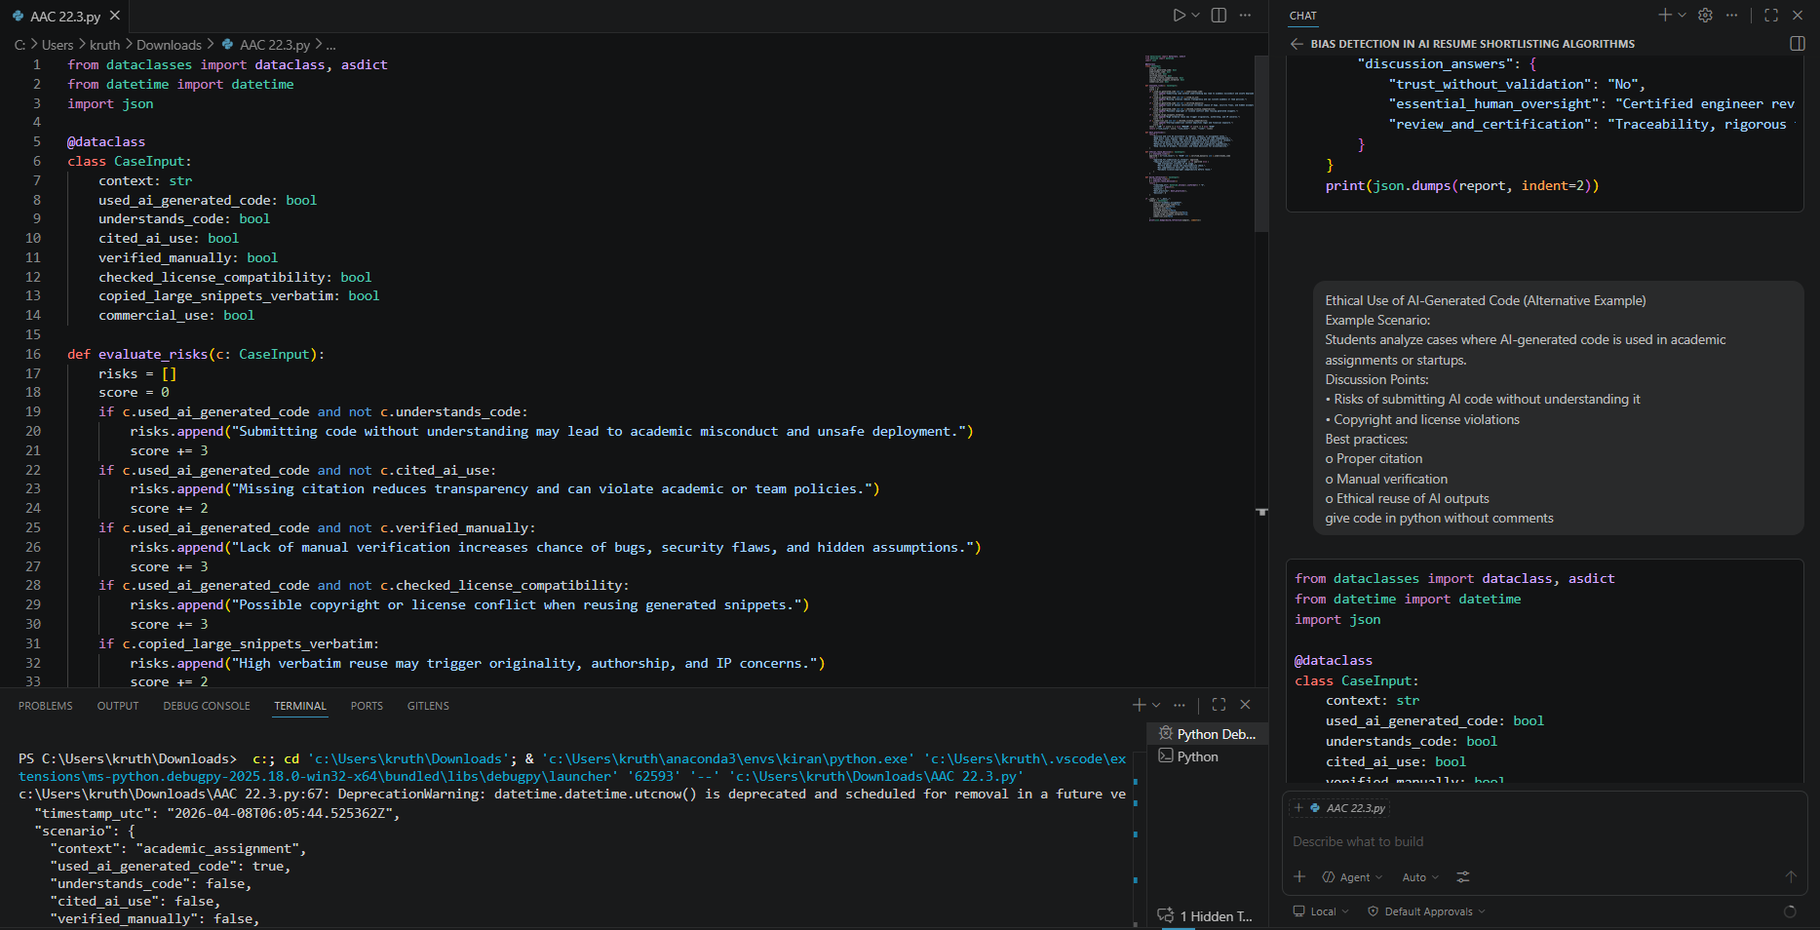

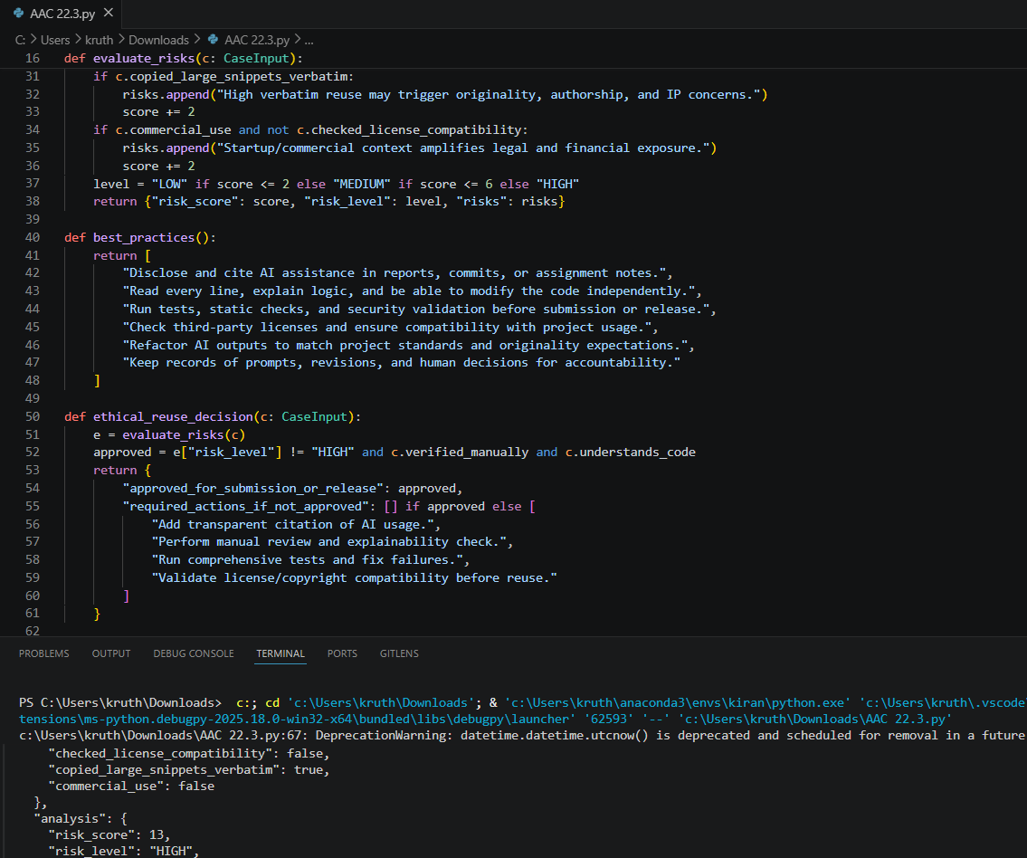

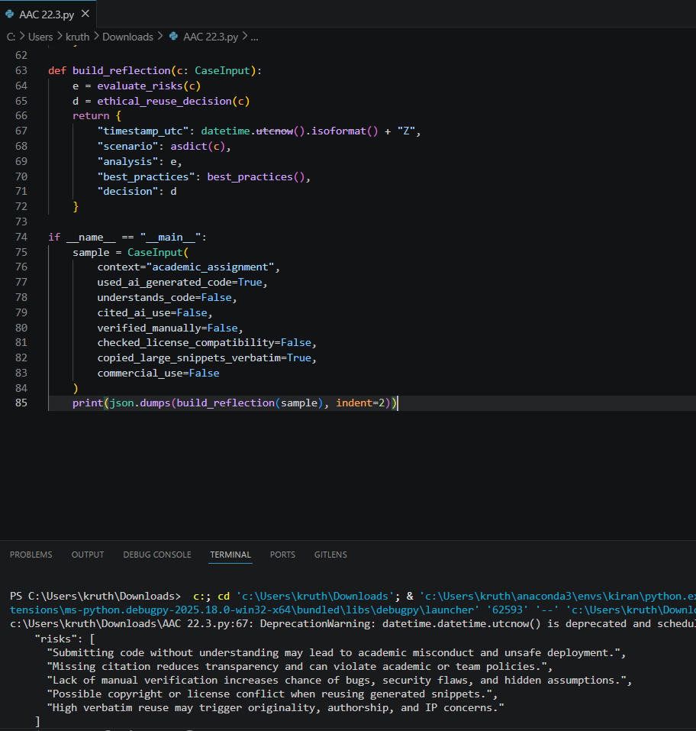

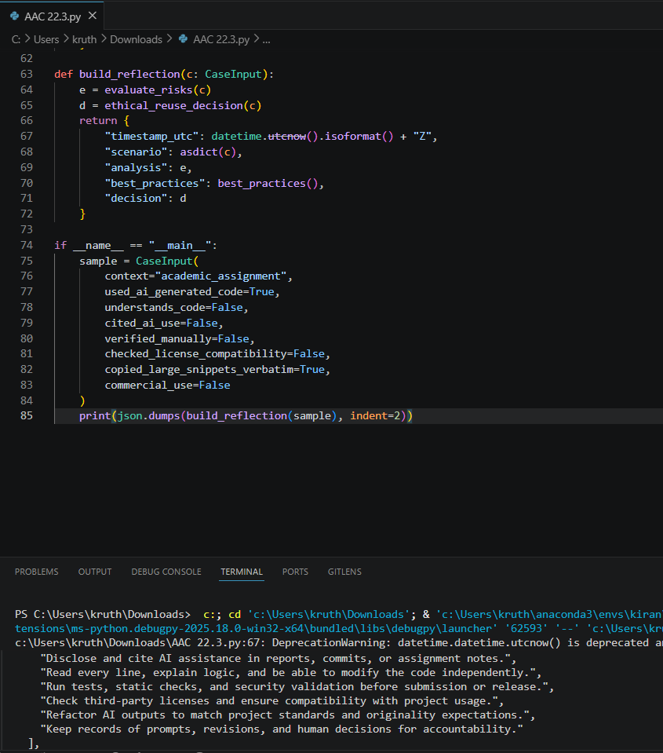

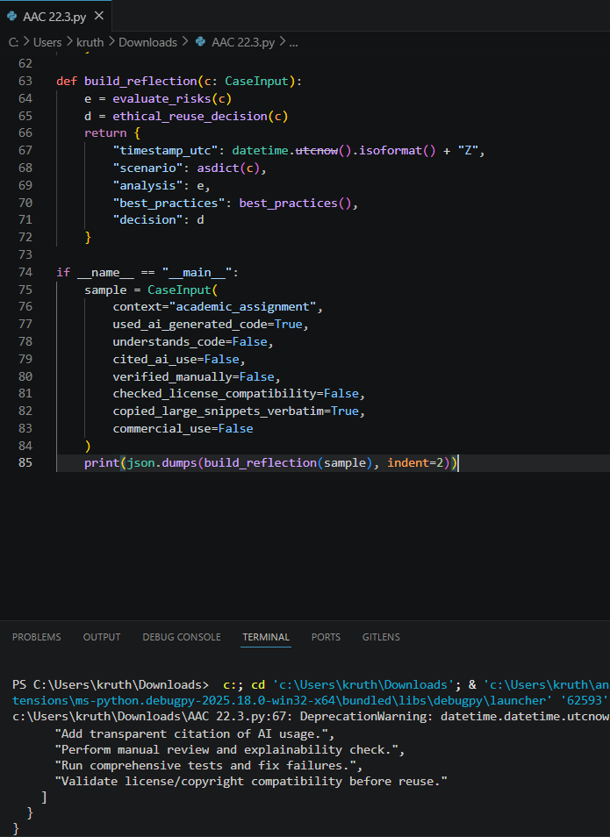
Note: Report should be submitted as a word document for all tasks in a single document with prompts, comments & code explanation, and output and if required, screenshots.

